Steps for Publishing a project on local folder

- Create a project named CrossPlatformDemo on dotnet.

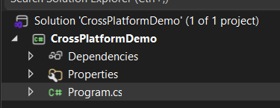

- Type the code you want to publish

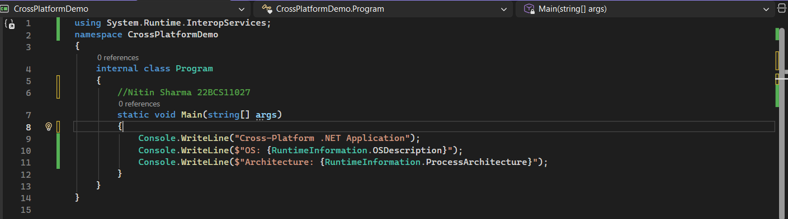

- Right click on project and click Publish.
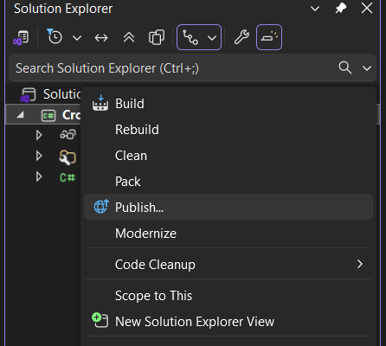
- Edit the desired settings before publishing

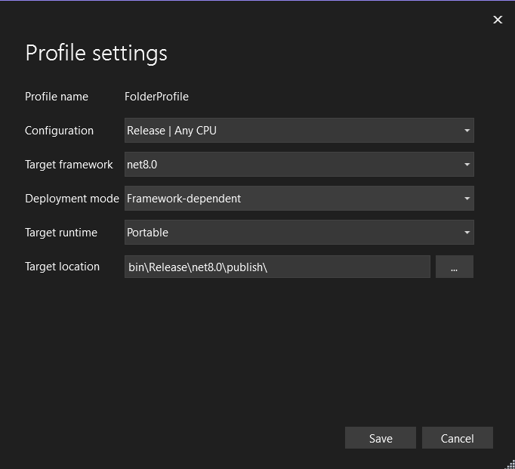

- Confirm the targeted runtime you are aiming for.

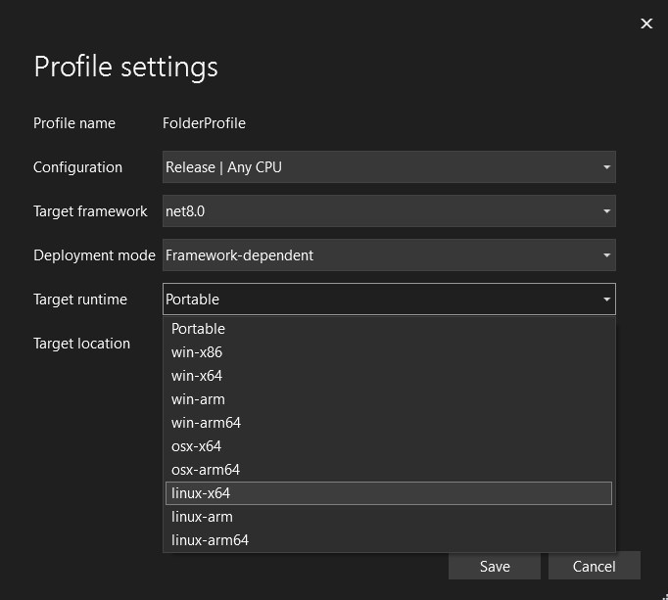
- Save and click on “publish” to publish your project.

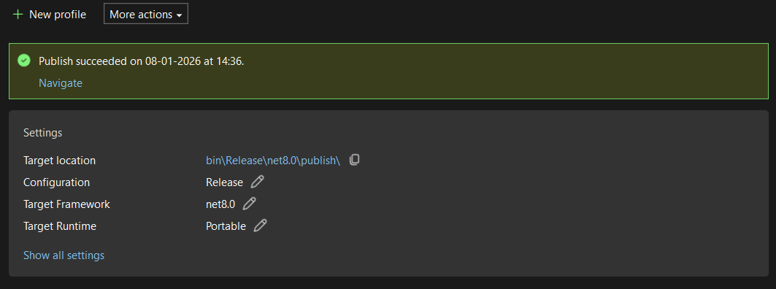

- The project is saved on the local machine like for me it is saved at:

C:\Users\nitin\source\repos\CrossPlatformDemo\CrossPlatformDemo\bin\Release\net8.0\publish

NOTE:
In step 4, we have 2 options for Deployment mode:
- Framework dependent:
It means that the runtime is already installed in user’s device and we are not providing runtime in our package.

- Self-Contained:
It means that we are putting the runtime within our package so if the user do not have a CLR (Common language runtime), then he need not to install it. We will be providing it in our package.

